Fitbit API

*You need a fitbit device, a fitbit app on your mobile, and a laptop.*

1. Create a Fitbit account. You can create it on mobile app or Fitbit website.
2. Open [FitBit Web API Reference](https://dev.fitbit.com/build/reference/web-api/), click the “Register your application” link under “Quick Start”, item 2.
3. Register a new application.

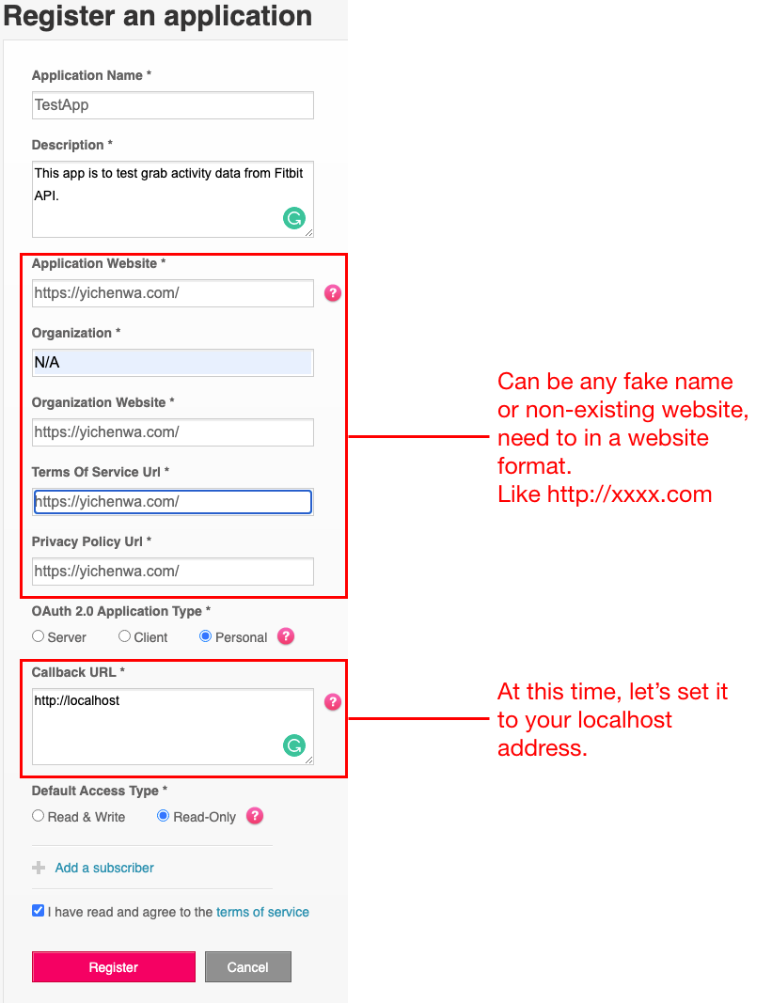

1. After click “Register”, you will see this page.

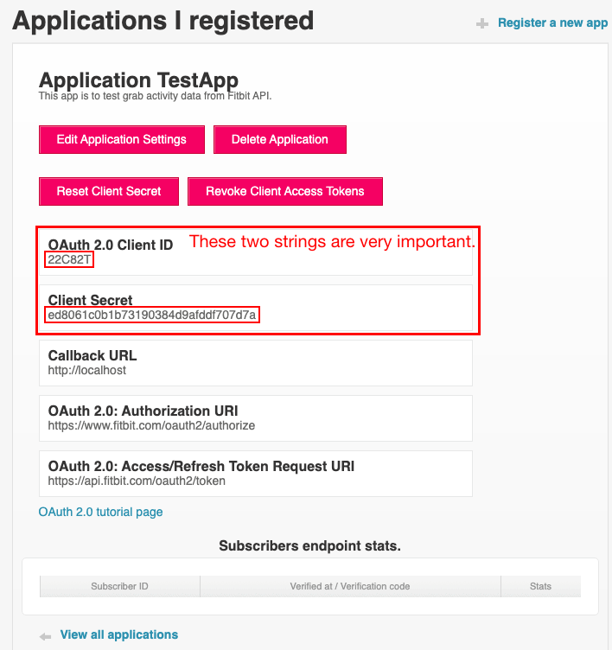

1. Go back to [FitBit Web API Reference](https://dev.fitbit.com/build/reference/web-api/), click the “Oauth 2.0 authorization” link under “Quick Start”, item 3.
2. Scroll down until you see these under **Authorization Page** title, copy the code and save in a document.

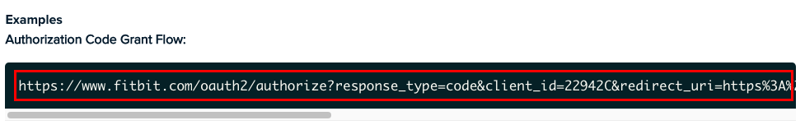

I just copy and paste it in a Visual Studio Code.

1. Change the Client ID to the Client ID you got in step 4.
2. Change the redirect_uri to the Callback URL you set in step 3.

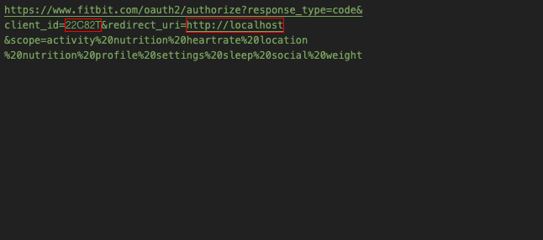

1. Copy the code you get, paste it in a searching engine address field. (I am using the Google Chrome)



1. Press “Enter”, you will see this form, select the data you want to access.

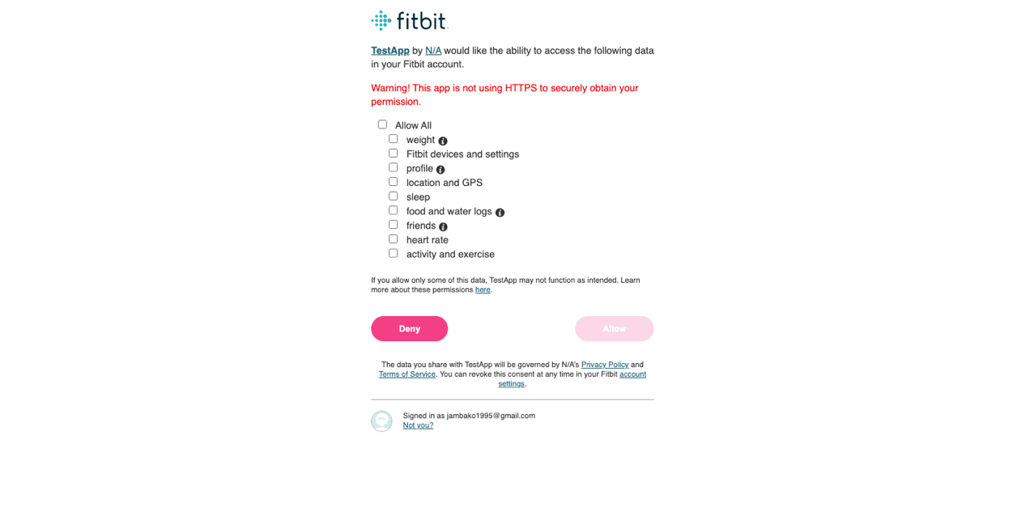

1. After click “Allow”, you will see these page, do not worry. Our aim is the code in the address field.

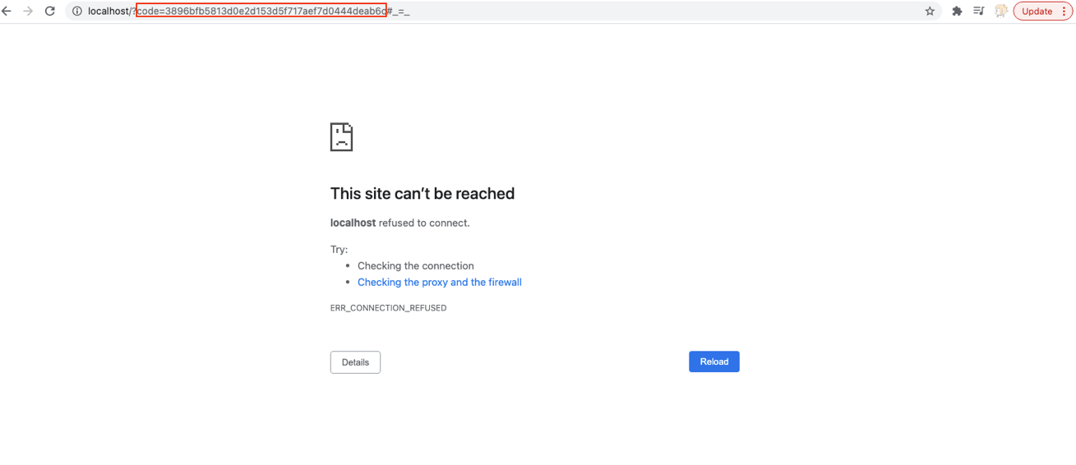

The code in Red box will be used to request an access Token.

*Reminder: The code will be expired after 10 minutes, you can repeat step 7 to get a new code.*

1. Go back to the [“OAuth 2.0 authorization flow”](https://dev.fitbit.com/build/reference/web-api/oauth2/) we access in step 5, scroll down until you see this under **Access Token Request** title.

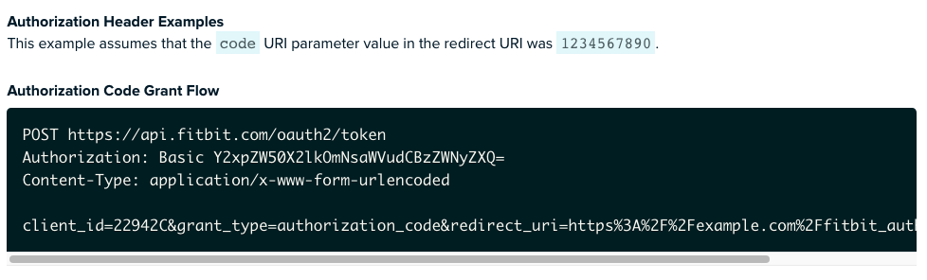

1. Open the [Base64encode](https://www.base64encode.org/) website, copy and paste the “client_id:client secret” in the test field, click “ENCODE” button.

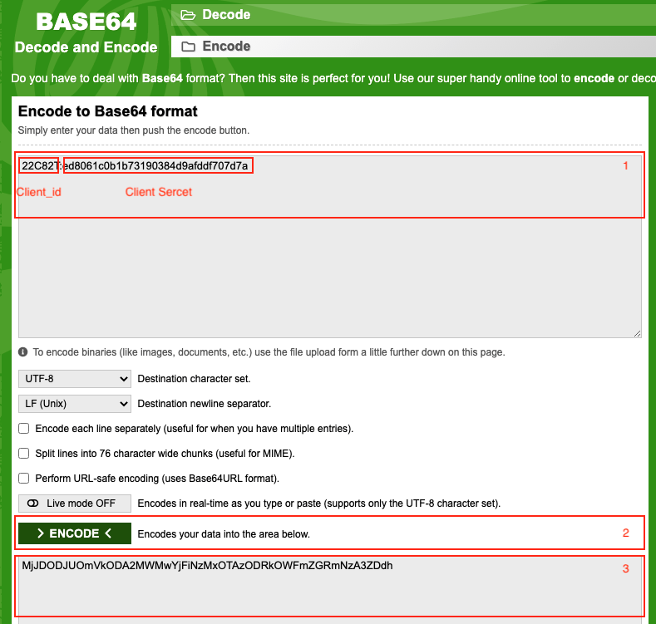

1. Open Postman, create a new tab and fill its Headers as the example you see in step 10. The code after “Basic” should be the Encode you got in Step 11, box 3.

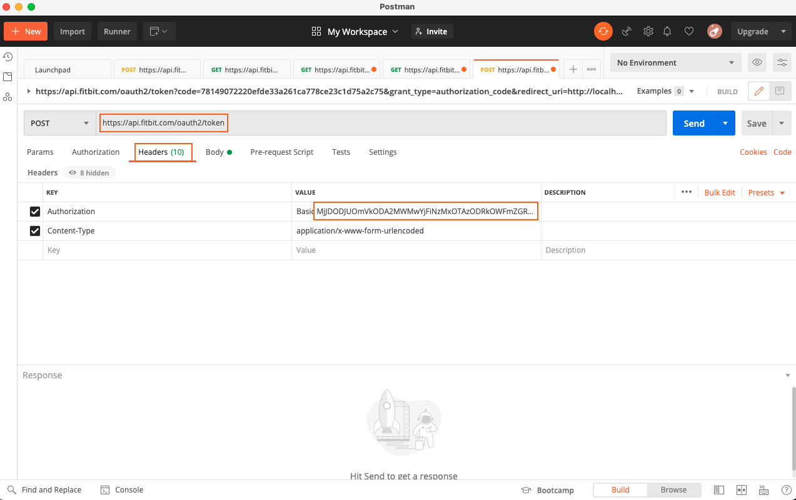

1. In the Params, fill it like these:

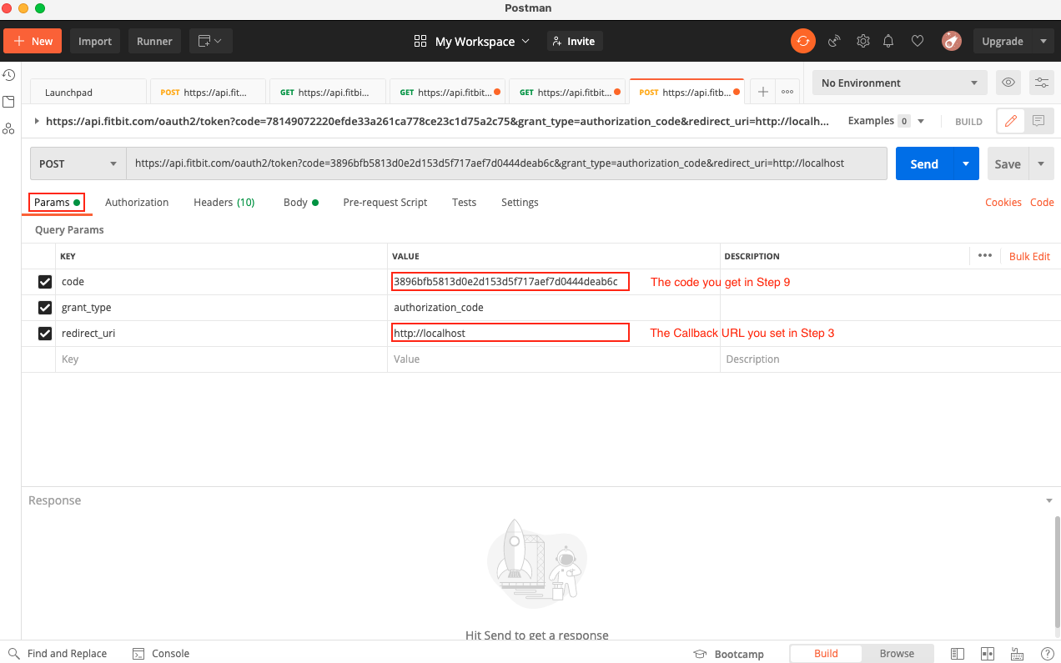

code: The code you got in Step 9

Grant_type: authorization_code

redirect_uri: The callback URL you set in step 2

You can also add params by following the **Body Parameters Chart** under the **Authorization Header** title.

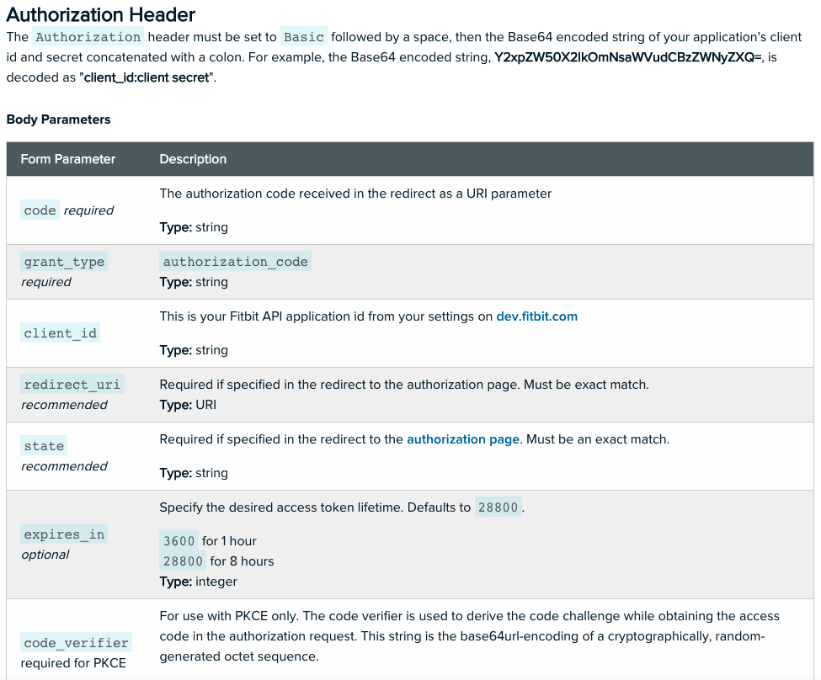

1. Then click “Send” button, you will get the access token.

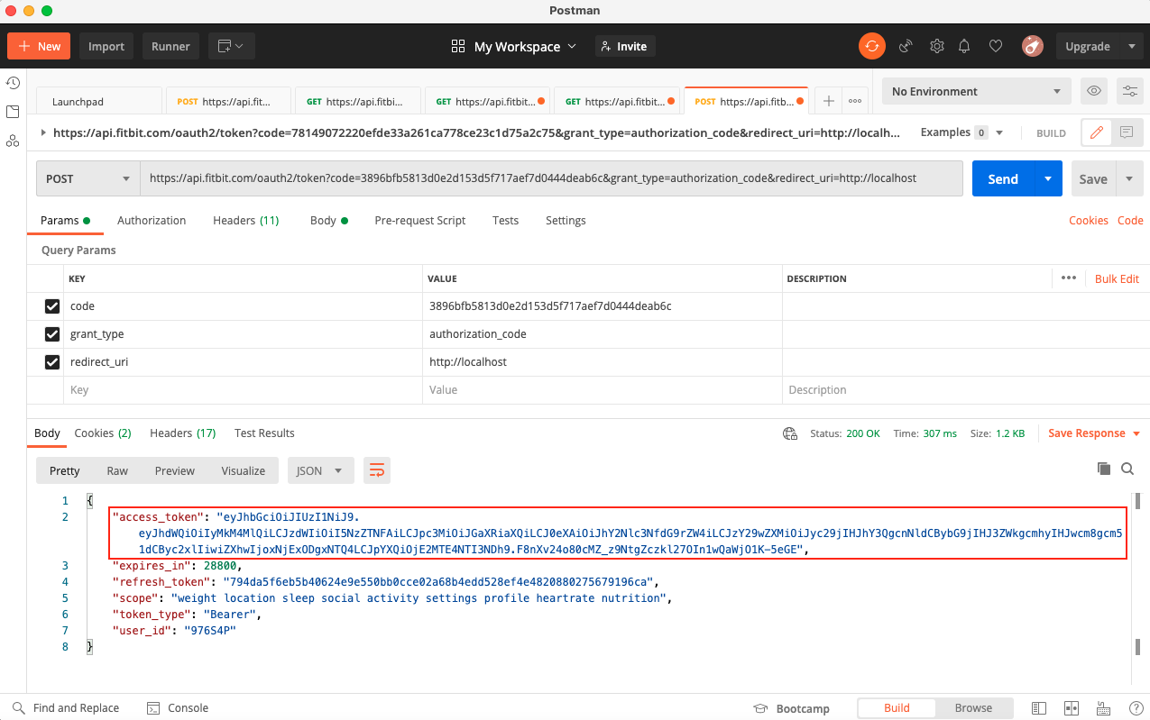

1. Go back to [FitBit Web API Reference](https://dev.fitbit.com/build/reference/web-api/), click the “API Explorer” link under “Quick Start”, item 4, you can see the Fitbit Web API list.
2. Open a new tab in Postman, in the Headers, type the access_token you got from step 14 after “Bearer “, edit the API you want to get, then click the “Send” button. You can see the data you want as the result.

